 | VDU WORKSTATION ASSESSMENT FORM |  |  |  |  |  | Form Number: HSF017  Version: 4.0  Issue Date: March 15  Procedure HSP 9.01
PART 1
Section 1: ABOUT THE VDU USER
Name of VDU User |  | Click here to enter text. |  | Date | Click here to enter a date.
Name or VDU Assessor or Line Manager |  |  | Click here to enter text.
Position of Workstation (Room / Area) |  |  | Click here to enter text.
Section 2: ABOUT YOUR VDU USE
Please indicate below what you consider to be part of your VDU use |  |  |  |  |  | Yes |  | No
Are you highly dependent on VDU use or do you have little choice about using a VDU?

Do you normally use a VDU for continuous or near continuous spells of an hour or more at a time and use it in this way more or less daily?

Do you perform quick transfer of information i.e. data inputting?

Does your work involve high levels of attention and concentration on the VDU for a prolonged period?

If any of the above statements apply, then you are defined as a VDU user, you must now complete Part 2 of this form, ‘Workstation Assessment’. If you are unsure, please speak with your VDU Assessor or Line Manager.

Section 3: ARE THERE OTHER WAYS THAT YOU WORK?
If any of the statements below apply, you must also be provided with and complete the ‘Setting up a Temporary Workstation’ user checklist [HSF078] |  |  |  |  |  | Yes |  | No
Do you work from home?

Do you have use of a ‘hot desk’ or share your workstation with another user?

Do you have use of a portable computer i.e. laptop?

If you use a portable computer for an hour or more, it may not meet the minimum requirements, which are a separate keyboard, mouse and screen / screen raiser. Do you have this equipment for your portable computer?

Section 4: WHAT ABOUT PART 2 OF THIS FORM?
Having completed Part 1 of this form |  |  |  |  |  | Yes |  | No
Are you defined as a VDU User, do you need to complete Part 2 of this form? If yes, please complete Part 2

PART 2 – WORKSTATION ASSESSMENT
Section 1: YOUR CHAIR
Please answer yes or no to the following questions |  |  |  |  |  |  |  |  |  |  |  |  | Yes | No
 |  |  |  | Ability to swivel?
 |  |  |  | Adjustable back rest?
 |  |  |  | Adjustable height?
 |  |  |  | Stability?
 |  |  |  | Five Castors?
 |  |  |  | Manoeuvrability?
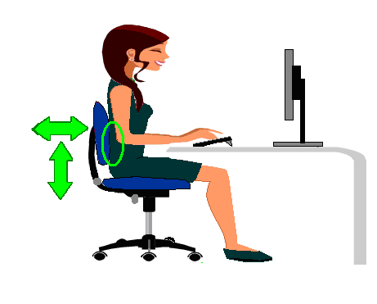 |  |  |  | Are you able to adjust the back rest so that it provides support to the lower and middle part of the back?
 |  |  |  | Can you adjust the seat height and position the chair, so that when your fingers are touching the middle row of keys, your elbows are kept at a right angle?
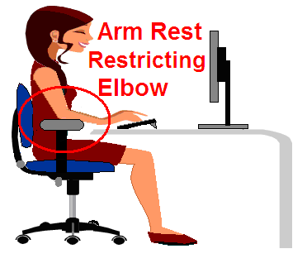 |  |  |  | Can the armrests be adjusted or removed?
Section 2: YOUR SCREEN
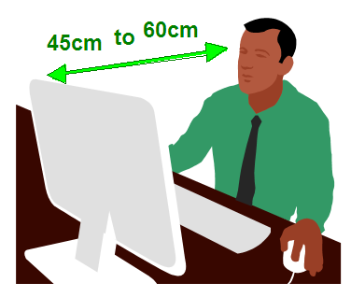 |  |  |  | Is the screen at a viewing distance of between 45cm and 60cm and is the top of the screen level with your eyes?
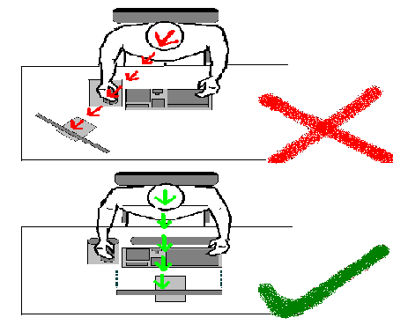 |  |  |  | Can you face the screen directly, without needing to turn your head?
 |  |  |  | Can the screen be |  |  |  |  |  |  |  |  | Yes | No
 |  |  |  | Tilted?
 |  |  |  | Raised?
 |  |  |  | Swivelled?
 |  |  |  | Adequate in size?
 |  |  |  | Free from flicker?
 |  |  |  | Provided with controls to adjust the brightness and contract?
 |  |  |  | Free from glare?
Section3: YOUR DESK
 |  |  |  | Does the size of the desk enable you to have a flexible arrangement of your equipment? i.e. computer equipment, desk, fan, stationery and phone
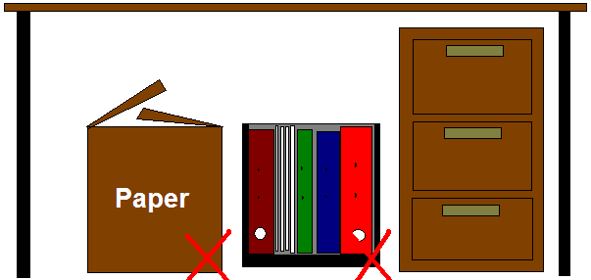 |  |  |  | Are you able to sit down and get up from your desk without any restriction?
 |  |  |  | Do your feet rest comfortably flat on the floor?
 |  |  |  | If applicable, where a document holder has been provided, is it adjustable and stable?
Section 4: YOUR KEYBOARD AND MOUSE
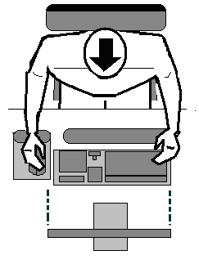 |  |  |  |  | Is the keyboard directly in front of the screen and not offset to one side?
 |  |  |  |  | Is there sufficient room in front of the keyboard and mouse to support the hands and wrists during pauses in keying?
 |  |  |  |  | Is the keyboard and mouse in a position so that they do not require stretching of the arms (keeping your elbow under your shoulders)?
 |  |  |  |  | Does the keyboard have a matt finish to avoid glare, is it stable, with clearly marked keys and the ability to tilt?
 |  |  |  |  | Does the mouse allow for easy operation of your computer?
Section 5: YOU / YOU AND YOUR WORK AREA
Answer the following in relation to your work area and working environment |  |  |  |  |  |  |  |  |  |  |  |  | Yes | No
Have you had sufficient training / information on the use of the computer software, adjusting your workstation and safe use of the VDU?

Do you take regular breaks away from the screen?

Can you use your VDU workstation without being disturbed by glare / reflection from the windows / lights?

Can you work at your VDU workstation (or after use) without experiencing poor vision, dry eyes or headaches?

Can you work at your workstation (or after use) without experiencing aches, pains, tingling or pins and needles in the hands, wrists, neck, back, shoulders or arms?

Can you use your VDU workstation without suffering undue stress i.e. social isolation, poor job design, software problems?

Do you find the following room conditions satisfactory? |  |  |  |  |  |  |  | Temperature?
 |  |  |  |  |  |  |  | Humidity?
 |  |  |  |  |  |  |  | Ventilation?
 |  |  |  |  |  |  |  | Noise?
Please note: Where problems are being experienced, make adjustments using this assessment to help remedy those problems. If the adjustments to the workstation have not remedied the problem, refer the matter to your Line Manager

PART 3 – ASSESSMENT RESULT AND REVIEW
Section 1: LINE MANAGER / VDU ASSESSOR
 |  |  |  |  |  |  |  |  |  |  |  |  | Yes | No
Have you surveyed the actual working position and layout of the designated user’s workstation using the ‘Assessment Guidance’ [HSF018] to meet the minimum standard?

Section 2: VDU / WORKSTATION ACTION PLAN
Action required |  |  |  |  |  |  |  |  | Date action taken | Assessors signature |  |  | Issue(s) resolved?
 |  |  |  |  |  |  |  |  | Date action taken |  |  |  | Yes | No
Click here to enter text. |  |  |  |  |  |  |  |  | Click here to enter a date. | Click here to enter text.
Click here to enter text. |  |  |  |  |  |  |  |  | Click here to enter a date. | Click here to enter text.
Section 3: ASSESSMENT SATISFACTION
Please sign to confirm that you are satisfied with the VDU workstation assessment
VDU Assessor or Line Manager |  |  | Sign Click here to enter text. |  |  |  |  |  |  |  |  | Click here to enter a date.
VDU User |  |  | Sign Click here to enter text. |  |  |  |  |  |  |  |  | Click here to enter a date.
Section 4: ANNUAL REVIEW
Date of review | Still valid? | Yes |  |  |  | No | User signature |  |  |  | Manager / Assessor

