Email signature
We have a corporate template for all employees to use as their email signatures. This unifies us as an organisation and helps convey our high standard of professionalism.
Here is a guide for creating your corporate email signature, including how to ensure your email signature is accessible.

Customise the email signature template shown below.

The email signature template uses Calibri, our chosen system font, for optimum accessibility. This is now the default font set across the council’s email network. Please do not change the font.

We have set the font size of the name to 12pt and use bold to add emphasis. The rest of the copy is set to 11pt, the minimum recommended size. You can increase the font size, but your name should always be 1pt size bigger and in bold.
Please do not re-size the council’s logo.
Once created, add the signature to your Outlook’s signatures
Either:
- Create a ‘New Email’, select ‘Signature’ in the toolbar, ‘Signatures…’ at the bottom of the dropdown menu
- Select ‘File’ in the top bar, ‘Options’ in the bottom left panel, ‘Mail’ on the left panel in the pop-up box and the ‘Signatures…’ button on the right
A pop-up box will appear, select your current email signature, or if you don’t have one select ‘New’.
Copy and paste your customised email signature into the ‘Edit signature’ box.
___________________________________________________________________________
Template:

Kind regards

Cllr <Name> <Surname>
Essex County Councillor for <Elected Area> Division

County Hall, Market Road, Chelmsford, CM1 1LX
<Tel number>
<cllr.name.surname@essex.gov.uk>



www.essex.gov.uk

I follow the Essex County Council standard privacy notice.
This tells you how I deal with personal information

Example signature

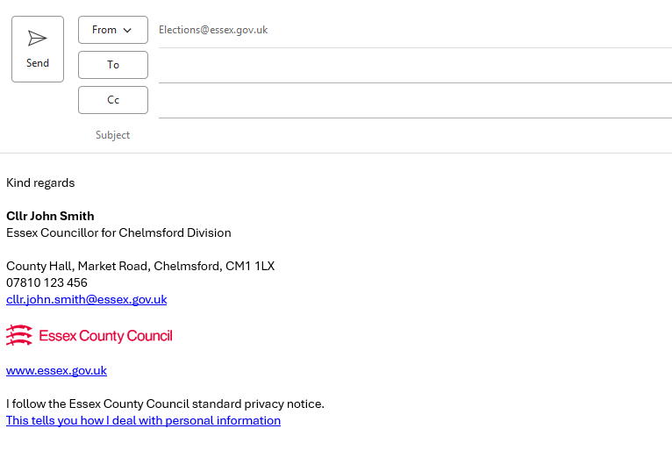

Other useful brand guidance and templates can be found here: Our brand | Essex Intranet

